

**ECET 400: Senior Project**

**Test Procedure**

**Title Project: Automatic Rear-View Mirror**

**Professor:**

**Alex Blinder**

**Students:**

**Valentina Clavijo**

**Diego Andrade**

**Kyuung (Casey) Cha**

**Nigel Ng**

**Mohammad Rahman**

**Date: 11/11/24**

# **Table of Contents**

**Table of Contents 2**

**1.0 Introduction 5**

**2.0 Deliverable Summary Table 7**

**3.0 Hardware/Software Deliverable 10**

**3.1 Software (Eye Tracking in Pi) 10**

**3.1.1 Software Test Procedure 11**

Figure #1: Camera Point of View 12

**3.2 Hardware (Motor interface with Housing Unit, Ball Joint, and Monopole Gear) 13**

**3.2.1 Hardware Test Procedure 14**

Figure #2: Housing for Motor 2 Figure #3: Monopole Gear Connected to Motor 2 Housing 17

Figure #4: Opening of the Housing Unit for Motor 1 Figure #5: Driveshaft connected to Motor 2 Housing 17

Figure #6: Ball Joint lids 18

Figure #7: Ball Joint lids 18

**3.3 First Prototype 19**

**3.3.1 First Prototype Test Procedure 20**

**3.4 Final Prototype 23**

**3.4.1 Final Prototype Test Procedure 24**

**4.0 Appendix 26**

**4.1 High Level Block Diagram of Project 26**

Figure #8: High Level Block Design 26

**4.1.1 Camera Detection 26**

**4.1.2 Microcontroller 26**

**4.1.3 Motors 27**

**4.1.4 Mirror Adjustment 27**

**4.2 Second Level Block Diagram of Project 28**

Figure #9: Second Level Block Design 28

**4.2.1 Explanation of Diagram 28**

**4.3 Schematics 30**

Figure #10: Schematic 30

**4.4 Flow Charts & Software 32**

Figure #11: Flowchart 32

**4.5 Parts Data Sheets 33**

**4.5.1 Raspberry Pi 4 Model B datasheet 33**

Figure #12: Raspberry Pi 4 Model B Pinout Diagram 33

Figure #13: Minimum & Maximum Voltage Input 33

Figure #14: Raspberry Pi Pinout Diagram 34

**4.5.2 Raspberry Pi Camera Module V2 datasheet 35**

Figure #15: Raspberry Pi Camera Module V2 35

**4.5.3 Greartisan Gear Motor datasheet 36**

Figure #16: Greartisan DC 12V 50RPM, 37mm Diameter Gearbox 36

**4.5.4 3 mm LED Datasheet 37**

Figure #17: 3mm LED Datasheet 37

**4.5.5 L293D Datasheet 38**

Figure #18: L293D Push-Pull Four Channel Drivers with Diodes, Block Diagram 38

Figure #19: L293D, Pin Connections 38

**5.0 References 40**

| **Table of Figures** | |
| --- | --- |
| **Figure** | **Page** |
| **Figure #1: Camera Point of View** | **12** |
| **Figure #2: Housing for Motor 2** | **17** |
| **Figure #3: Monopole Gear Connected to Motor 2 Housing** | **17** |
| **Figure #4: Opening of the Housing Unit for Motor 1** | **17** |
| **Figure #5: Driveshaft connected to Motor 2 Housing** | **17** |
| **Figure #6: Ball Joint lids** | **18** |
| **Figure #7: Ball Joint lids** | **18** |
| **Figure #8: High Level Block Design** | **26** |
| **Figure #9: Second Level Block Design** | **28** |
| **Figure #10: Schematic** | **30** |
| **Figure #11: Flowchart** | **32** |
| **Figure #12: Raspberry Pi 4 Model B Pinout Diagram** | **33** |
| **Figure #13: Minimum & Maximum Voltage Input** | **33** |
| **Figure #14: Raspberry Pi Pinout Diagram** | **34** |
| **Figure #15: Raspberry Pi Camera Module V2** | **35** |
| **Figure #16: Greartisan DC 12V 50RPM, 37mm Diameter Gearbox** | **36** |
| **Figure #17: 3mm LED Datasheet** | **37** |
| **Figure #18: L293D Push-Pull Four Channel Drivers with Diodes, Block Diagram** | **38** |
| **Figure #19: L293D, Pin Connections** | **38** |

# **1.0 Introduction**

The automatic rearview mirror will lead to an improvement in safety and convenience by addressing the problem of frequent mirror changes in shared vehicles and will also help reduce blind spots and suboptimal viewing angles from mirror positioning. This product will function by using the position of the driver's eyes via a camera connected to the mirror, which will align itself with the driver's eye line and position itself at the correct angle according to the rear window and driver. The camera searches for the driver's eyes by using dots projected onto the eyes and perpendicular dots that serve as markers for the camera to align itself to the driver's eye line. The system will determine the angle of adjustment between both markers and then signal the motors to start moving the ABENICS ball joint to rotate to the optimal position. Once the mirror is facing the driver, the system will use dots placed at the rear window to determine where small adjustments are needed to allow for the best possible view of the rear window.

The product comes with powered adjustment that uses the directional pad in case of a failure. The system will also warn the driver using an LED light when the adjustment is occurring and will turn off once the adjustment is complete.

To turn this concept into a successful final product, it needs to go through key phases beginning from initiation, prototyping, execution, to testing and validation. The project has undergone the initiation phase and is now going through prototyping. As the team assembled the hardware for the first prototype, they encountered a few problems, such as the Raspberry Pi camera module not connecting to the microcontroller, so a USB web camera will be used temporarily for testing until the module arrives. Another issue was the 3D printer overheating, which was resolved by using new parts and updates. The team will ensure the product is fully functional and works as intended, so it will be put through various test scenarios to confirm everything works seamlessly. This also requires testing the product at each stage of development. The four deliverables will test different aspects of the product.

# 

# **2.0 Deliverable Summary Table**

| **Deliverable**  **& Its Title** | **Description** | **Number of Steps in Testing** | **Due Date** |
| --- | --- | --- | --- |
| **Software** | This deliverable aims to first get the testing environment setup for the Raspberry Pi then proceed to test the lighting, eye tracking, along with data calculation results. | 1. Test Environment  2. Eye Tracking  3. Performance  4. Data Calculation | **11/11/2024** |
| Eye Tracking Software Running Optimally in Raspberry Pi |
| **Hardware** | Inside this deliverable the team will be testing the motor interface in conjunction with the ball joint and monopole gear. It will allow the team to confirm and analyze any weak points in the design and the interfacing between the motor, ball joint, and monopole gear. | 1. Measure battery values (Voltage and Amperage).  2. Assemble motor housing with motor 2 and attach monopole gear.  3. Assemble housing unit with motor 1 and motor 2.  4. Join Ball Joint 3D with the housing unit.  5. Provide power to motor 1 and motor 2 (12V Max and 0.6A Min).  6. Test inputs on D-pad and push buttons. | **11/11/2024** |
| Motor interface with Housing Unit, Ball Joint, and Monopole Gear |
| First Prototype | This deliverable will include the interface between the software and hardware. The team will be testing the eye tracking in conjunction with the ball joint. This will allow us to determine if there are any issues with the program or design. | 1. Test & troubleshoot that power and optimal voltage runs through all components and devices  2. Camera and eye tracking software operating the motors  3. Directional Pad manual operation of the motors  4. Check to see if LED illuminates  5. Test movement of the motors inside the housing unit  6. Test movement between motor and examine any issues with the ball joint | **11/14/2024** |
| Final Prototype | The final deliverable will have the updated design and software. It will define the final prototype and its functions. | 1. Finalize tests & troubleshooting that power and optimal voltage runs through all components and devices  2. Tests pushbuttons for automatic and manual operation switching  3. Camera and eye tracking software operating the motors in smooth unison  4. Directional Pad manual operation of the motors tests  5. Finalize test of motors’ movement inside the housing unit  6. Test contact interaction between motor and monopole gear  7. Finalize contact interaction movement between monopole gear and ball joint  8. LED indicator illuminates and blinks throughout mirror adjustment | **11/14/2024** |

# 

# **3.0 Hardware/Software Deliverable**

## **3.1 Software (Eye Tracking in Pi)**

To test the functionality of the eye-tracking software on a Raspberry Pi without an integrated screen, an external monitor needs to be connected. The software should display the camera feed on this external monitor. If the monitor shows the camera feed, the system is functioning correctly. This setup ensures that the Raspberry Pi's camera and software are working as intended.

Once the setup is complete, the next step is to assess the eye-tracking functionality. The driver’s head should be positioned within the camera’s field of view. The green dots that represent target points should precisely follow the driver’s eye movements even when the head shifts position. It is also important to monitor the FPS counter on the screen to verify that the software operates at optimal performance levels.

To validate the accuracy of data calculations, the driver should move around the head to try to get the green dots and the red dots aligned. The screen will display vector values, representing the distance between target points and reference points. These values are expected to decrease as the adjustment process progresses. The process is considered complete when the vector value falls below the threshold of ±5 pixels, which will show GOOD text on the screen.

### **3.1.1 Software Test Procedure**

| **Objective** | **Step** | **Test Case** |
| --- | --- | --- |
| Test Environment | 1. Run the software  2. Check if screen is displaying | * Camera’s perspective is clearly visible on the frame |
| Eye Detection | 1. Position the driver’s face to be within camera’s field of vision  2. Move the face around  3. Examine the positions of the target points (green dots) on monitor | * The target points are positioned correctly on the driver’s eyes * The target points follows the driver’s face |
| Performance | 1. Don’t position the driver’s face to be within camera’s field of vision  2. Examine the FPS value displayed on screen  3. Position the driver’s face to be within camera’s field of vision  4. Example the FPS value displayed on screen | * Framerate count maintains at least 15 FPS before and after eye detection |
| Data Calculation | 1. Position the driver’s face to be within camera’s field of vision  2. Move the face around  3. Examine the vector values displayed on the screen | * The vector values of two target points are displayed * The distance vector value should change as the face is moving * When the distance vector is below ±5 pixels, the GOOD Text comes out |

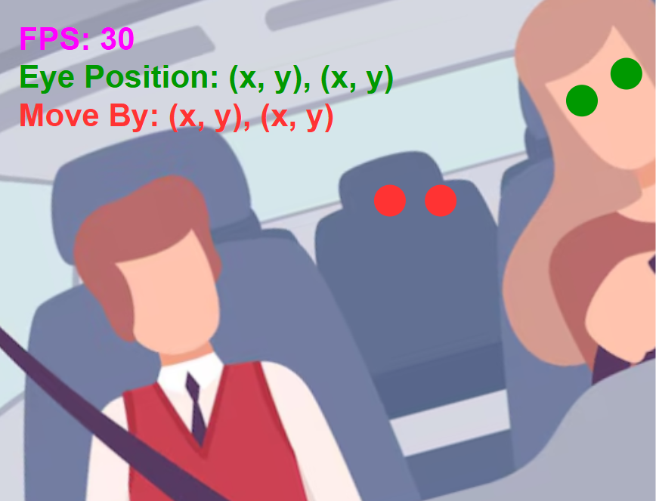

**Note:** This test should be performed three times.

## 

## 

#### 

#### 

#### **Figure #1: Camera Point of View**

## 

## 

## **3.2 Hardware (Motor interface with Housing Unit, Ball Joint, and Monopole Gear)**

This test deliverable will determine the interface between housing unit, motors, monopole gear, and ball joint. It will also confirm that the battery power is sufficient, this will ensure proper interaction between components and prototype. Additional reasons for conducting this test include:

* Verify if the hardware meets the design specification requirements.
* Check to see if directional pad/push buttons are set up properly by looking at all the connections and basic operations.
* Make sure the system is interfacing as designed and determine interface errors.

After the power is switched on, the testers will check the voltage at source/battery. The testers will utilize a multimeter to measure values, and software to determine inputs/outputs are functioning as intended. The testers will then examine the motor housing along with the motor and monopole gear and check to see if the motor moves within the housing and if the screw fits.The monopole gear will be checked to see if it makes smooth contact with the drive shaft. Similar steps will be used to examine the housing unit with motor 1 and motor 2 and also the ball joint with the housing unit.

### **3.2.1 Hardware Test Procedure**

| **Test Case: Hardware Assembly** | | | | | |
| --- | --- | --- | --- | --- | --- |
| **Objective:**  The test is to verify the proper functioning and integration of the components of the automatic rearview mirror system, ensuring that each element, from the 3D printed parts to the input controls, operates smoothly and efficiently in both manual and automatic modes. This includes ensuring the smooth fit of moving parts, the frictionless rotation of the motors within their housing, the precision of manual control using the D-Pad, and the functionality of the mode switching buttons. | | | | | |
| **Equipment Required:**   * Multimeter * Multimeter Leads * 2 Greartisan DC Motors 12V 50 RPM * Motor Driver - L293D * 5 Screws - ½ inch diameter * 5 Nuts - ½ inch diameter | | | | | |
| **Step#** | **Procedure** | **Expected Result** | **Pass/Fail** | **Signature**  **Data/Time** | **Notes** |
| **1** | Using a multimeter, measure voltage being fed to **DC motors** by placing negative lead on the negative terminal of the motor and placing the positive lead on the positive terminal of the motor. | Voltage:  4.5V - 5.5V |  |  |  |
| **2** | Using a multimeter, measure voltage being fed to the **motor driver** by placing negative lead on the negative terminal of the motor and placing the positive lead on the positive terminal of the motor. | Voltage:  4.5V - 5.5V |  |  |  |
| **3** | Assemble motor housing with **motor 2** (See Figure #2 - Test Procedure Doc). | Motor 2 is secure/tight to motor housing, Terminals exposed |  |  |  |
| **4** | Align motor 2 screw hole to motor housing hole. | Motor 2 and motor housing holes align, Screw fits through housing hole |  |  |  |
| **5** | Use motor 2 screws to tighten the motor to the housing unit. | Motor is secure to motor housing |  |  |  |
| **6** | Attach rear motor housing. | Rear motor housing firmly encloses the motor housing |  |  |  |
| **7** | Slide motor 1 into the opening of the housing unit (See Figure #4 - Test Procedure Doc). | Motor 1 moves smoothly into the opening of the housing unit |  |  |  |
| **8** | Attach motor 2 assembly to motor 1 drive shaft. | Motor 2 is assembled firmly to motor 1 drive shaft to allow simultaneous movement |  |  |  |
| **9** | Confirm motor 2 assembly is sitting on the curved ridge (See Figure #5 - Test Procedure Doc). | Motor 2 assembly is sitting correctly on the curved ridge, securing proper space for movement |  |  |  |
| **10** | Use motor 1 screws to tighten the motor to the housing unit. | Motor 1 is tightened firmly to the housing unit |  |  |  |
| **11** | Attach monopole gear to motor 2 drive shaft (See Figure #3 - Test Procedure Doc). | Monopole gear fits firmly on motor 2 drive shaft ensuring proper transference of rotation |  |  |  |
| **12** | Take the ball joint and place it on top of the monopole gear (hold it in place). | Ball joint fits loosely to monopole gear |  |  |  |
| **13** | Place one of the ball joint lids on one side of the ball joint (See Figure #6 & 7 - Test Procedure Doc). | Ball joint lid fits and secures ball joint |  |  |  |
| **14** | Use ½ inch screws to secure the ball joint lid into place. | Ball joint lid fits firmly on one side of the ball joint |  |  |  |
| **15** | Repeat the process with the second lid, and use the last ½ inch screw to secure ball joint lids to each other. | Ball joint lid fits firmly to the housing unit |  |  |  |
| **16** | Ensure that the ball joint with the housing unit makes contact with the monopole gear. | Ball joint and housing unit make constant contact with the monopole gear |  |  |  |
| **17** | Connect positive lead of battery to positive side of battery and negative lead of battery to negative side of motor. | Motor rotates (clockwise) smoothly and it does not experience intensive heat or resistance |  |  |  |
| **18** | Repeat step 2 but connect negative lead to positive side of motor and positive lead to negative side of motor for counterclockwise. | Motor rotates counterclockwise |  |  |  |
| **19** | Connect pad controller to raspberry pi. | Microcontroller recognizes pad controller |  |  |  |
| **20** | Press each button for the Push Buttons and then the D-Pad. | Correct buttons pressed are shown as active on console |  |  |  |
| **21** | Check the console. | Console displays values |  |  |  |

**Comments:**

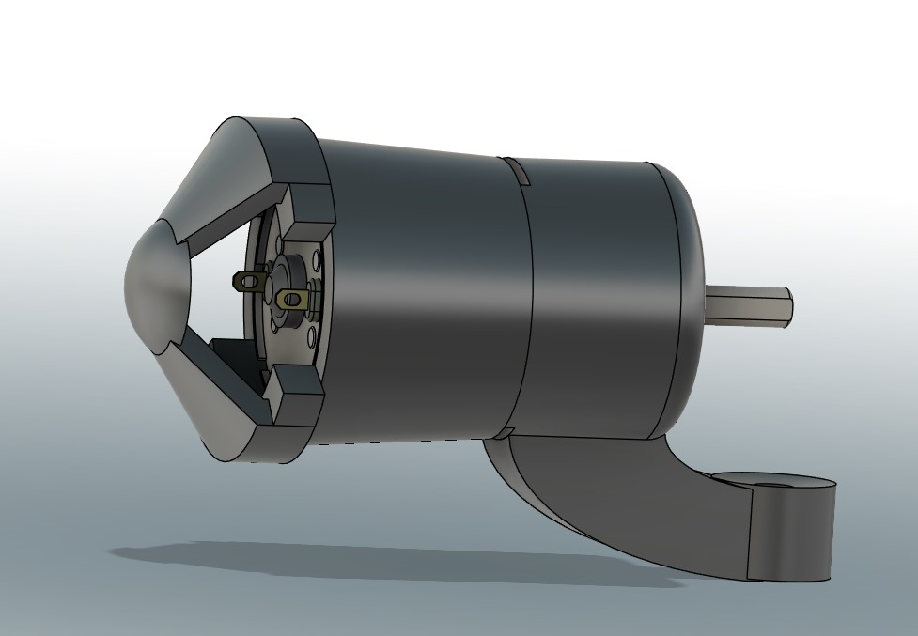 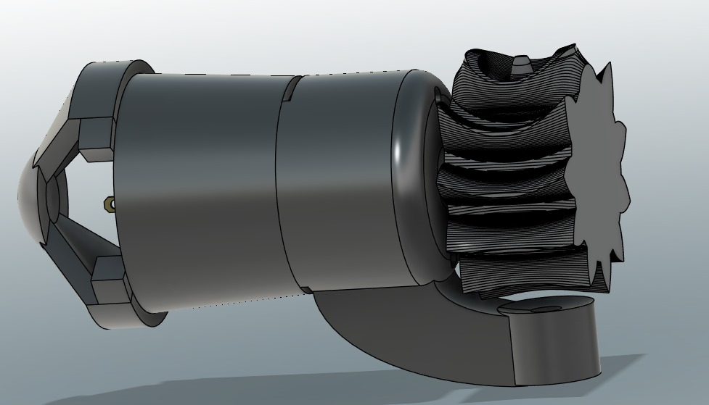

#### **Figure #2: Housing for Motor 2 Figure #3: Monopole Gear Connected to Motor 2 Housing**

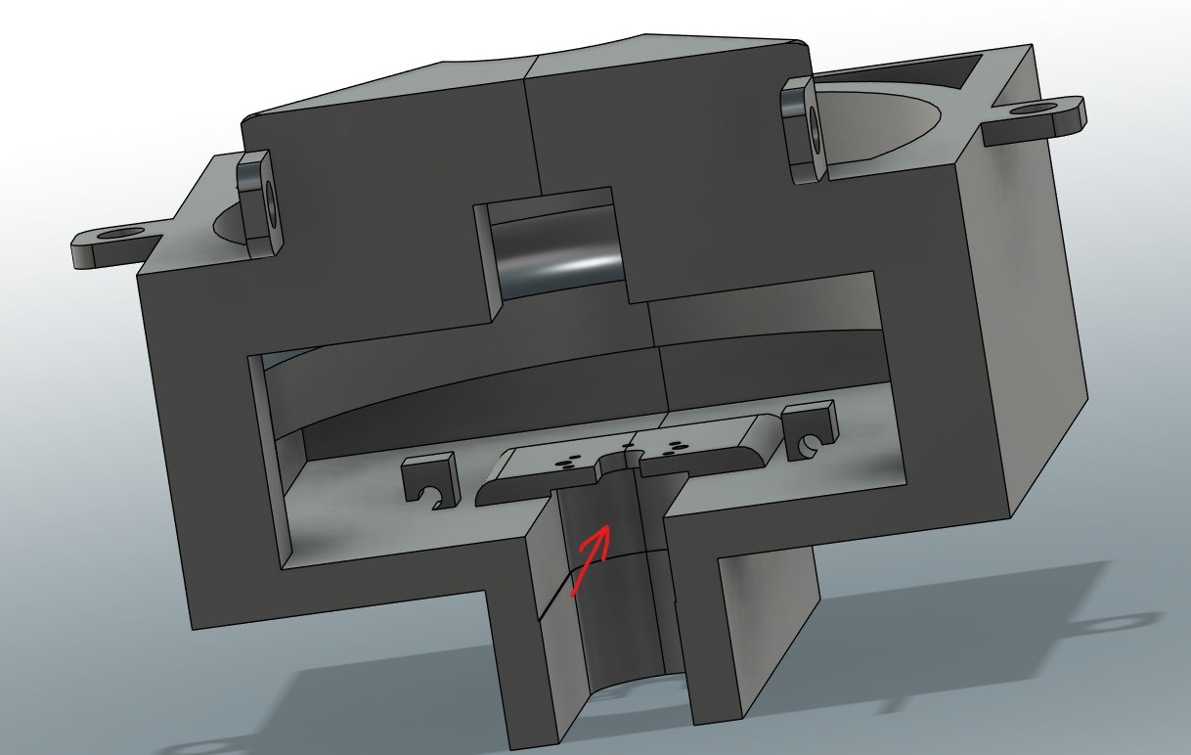 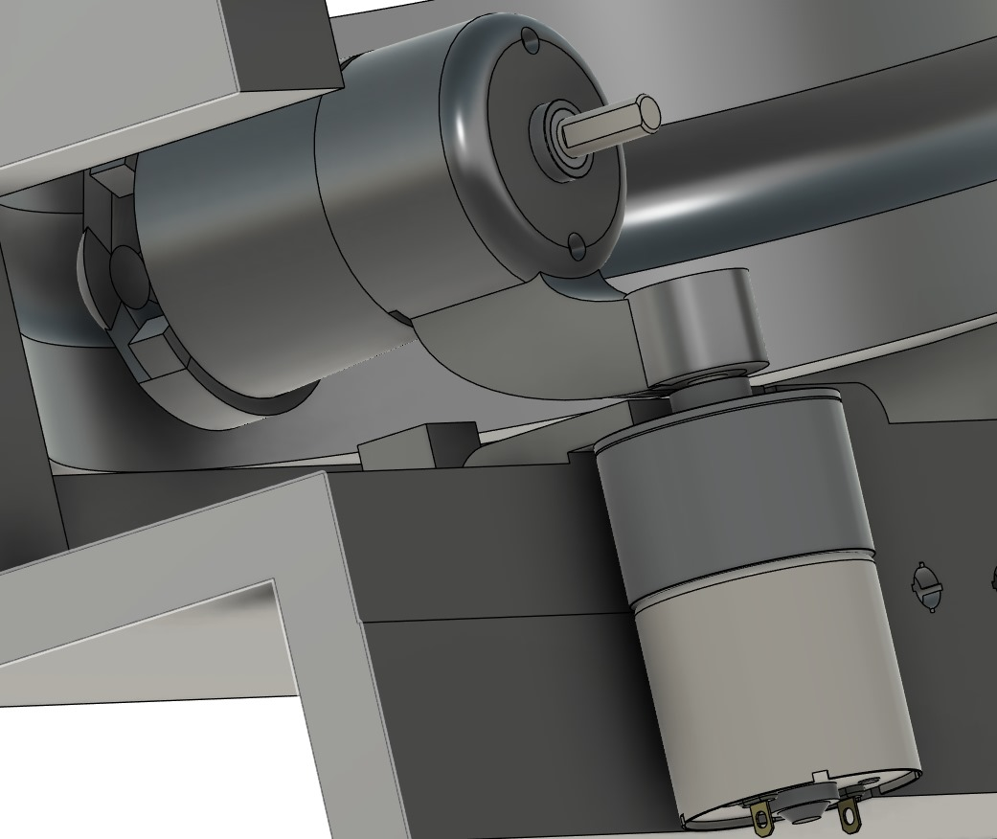

#### **Figure #4: Opening of the Housing Unit for Motor 1 Figure #5: Driveshaft connected to Motor 2 Housing**

#### 

#### 

#### **Figure #6: Ball Joint lids**

#### 

#### **Figure #7: Ball Joint lids**

## **3.3 First Prototype**

The first prototype is an attempt to combine the software and hardware and test out the first implementation of the project. In this deliverable the team will test the software compatibility with the motors, LEDs, and camera and also make sure the microcontroller performs the tasks using the I/O ports.

The team will run various tests for each component. It is necessary to make sure the proper voltage and current runs through each component to function properly and also to make sure it does not overheat.

The camera and eye tracking software will be tested to see if it works with the motors and the 3d printed parts like the ABENICS joint should be able to move smoothly with the monopole gear. Both the DC motors should function to control the components to either pitch,yaw or roll. The manual mode will also be tested using the d-pad to see if it can change adjustments in proper increment and speed and the push buttons should be able to toggle between automatic/manual mode.

There should be no input lag or delays in the system. Any design flaws that were not anticipated or caught in time will be fixed before the final prototype testing. The first prototype test will allow the team to rigorously assess the design and then improve and engineer it based on the findings.

### 

### **3.3.1 First Prototype Test Procedure**

| **Objective** | **Step** | **Test Case** |
| --- | --- | --- |
| Power/Battery | 1. Power on and connect power to components | * Test & troubleshoot that power and optimal voltage runs through all components and devices |
| Microcontroller & Motor Driver | 1. Powered on from battery, allowing operation and power flow to devices and components 2. Controls and activates the motors for manual D-Pad operation or automatic eye-tracking operation 3. Controls pitch, yaw, and roll movement through the motors | * Measure Voltage Input/Output * Using LEDs to show commands run through the Microcontroller * Using the motors and LEDs to show commands run through Motor Driver * Adjust code to ensure commands runs through to activate motor driver |
| Pushbutton & D-Pad | 1. Press push button to toggle between Manual and Automatic operation for mirror adjustment 2. Press and hold to make manual mirror adjustment to rear-view mirror 3. Press in each direction and observe rear-view mirror to check for input lag | * Measure Voltage Input/Output * Use LEDs to show PB & D-Pad works |
| Camera & Eye Tracking | 1. Position the driver’s face to be within camera’s field of vision 2. Move the face around 3. Examine the positions of the target points (green dots) on monitor 4. Check camera is powered on immediately after the Raspberry Pi is powered on 5. Scans vehicle cabin for driver’s eye level | * Measure Voltage Input/Output * Check frame rate * Check camera visuals through a facecam software * Adjust code to ensure Camera identifies driver eye level |
| Motors & Monopole Gear | 1. Controlled through manual or automatic operation 2. The first motor will control the roll for the other components within the housing unit 3. The second motor will control the pitch and yaw of the rest of the components 4. Attached to the second motor and makes contact with the ball joint 5. Ensure smooth contact and movement with the ball joint | * Measure Voltage Input/Output * Measure RPM with computer software * Motors operate at a fast consistent speed * Adjust code to ensure motors rotate * Adjust RPM in coding * Examine any issues for the contact between monopole gear and ball joint. |
| Ball Joint & Rear-View Mirror | 1. Makes contact with the monopole gear and is adjusted via the motors and monopole gear 2. Attached to back side of the rear-view mirror therefore adjusting the view out the rear windshield for the driver | * Make any adjustments to the print of the monopole gear and ball joint allowing smoother contact between the two |
| Enhancement | 1. Reprint 3D parts to ensure uninhibited movement 2. Adjust resistance and voltage to optimize device performance | * Ensure consistent and smooth component & device movement |

## 

## **3.4 Final Prototype**

The final prototype will incorporate all the improvements that were needed based on the insights obtained from the first prototype.This stage is essential as it will ensure that the product operates reliably according to design specifications and is suitable for the market.

Each hardware component from the motors to camera and software will be thoroughly tested again. Both automatic and manual mode functionality will be checked. There should be no delay or lag in the eye tracking system and all the issues found from the previous prototype will be reviewed again to see if they have been properly resolved.

By the end of this testing procedure the product should be ready as all the issues have been addressed and verified by various different test scenarios. However if the final prototype fails the team will have to re-evaluate the component choice or review the design specifications and the system will then be tested again.

### **3.4.1 Final Prototype Test Procedure**

| **Objective** | **Step** | **Test Case** |
| --- | --- | --- |
| Power/Battery | 1. Power on and connect power to components | * Test & troubleshoot that power and optimal voltage runs through all components and devices |
| Microcontroller & Motor Driver | 1. Power on 2. Send commands to the Raspberry Pi & Motor Driver | * Measure Voltage Input/Output * Using LEDs to show commands run through the Microcontroller * Using the motors and LEDs to show commands run through Motor Driver |
| Pushbutton & D-Pad | 1. Press push button to toggle between Manual and Automatic operation for mirror adjustment 2. Press and hold to make manual mirror adjustment to rear-view mirror 3. Press in each direction and observe rear-view mirror to check for input lag | * Measure Voltage Input/Output * Use LEDs to show PB & D-Pad works |
| Camera & Eye Tracking | 1. Position the driver’s face to be within camera’s field of vision 2. Move the face around 3. Examine the positions of the target points (green dots) on monitor | * Measure Voltage Input/Output * Check frame rate * Check camera visuals through a facecam software * Adjust code to ensure Camera identifies driver eye level |
| Motors & Monopole Gear | 1. Controlled through manual or automatic operation 2. The first motor will control the roll for the other components within the housing unit 3. The second motor will control the pitch and yaw of the rest of the components 4. Attached to the second motor and makes contact with the ball joint 5. Ensure smooth contact and movement with the ball joint | * Measure Voltage Input/Output * Measure RPM with computer software * Motors operate at a fast consistent speed * Adjust code to ensure motors rotate * Adjust RPM in coding * Examine any issues for the contact between monopole gear and ball joint. |
| Ball Joint & Rear-View Mirror | 1. Makes contact with the monopole gear and is adjusted via the motors and monopole gear 2. Attached to back side of the rear-view mirror therefore adjusting the view out the rear windshield for the driver | * Make any adjustments to the print of the monopole gear and ball joint allowing smoother contact between the two |

# **4.0 Appendix**

## **4.1 High Level Block Diagram of Project**

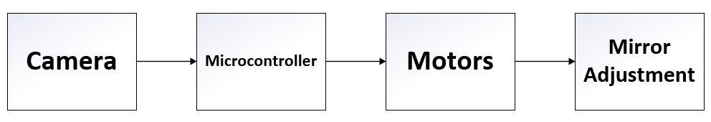

#### **Figure #8: High Level Block Design**

### **4.1.1 Camera Detection**

The camera detection block focuses on what the camera does and what it will operate once it is powered. Once turned on it will scan and detect the location of the driver’s eye line, then it will send that data to then be processed and activate the DC motors.

### **4.1.2 Microcontroller**

The microcontroller block focuses on processing the data that is sent from the camera as well as enabling other applications and components it’s connected to. Those components being pushbuttons to enable automatic operation with the camera and the eye tracking software, or manual operation with the directional pad. In addition, to the motor drive and connected DC motors to move the monopole gear to adjust the yaw, pitch, and roll of the mirror. Finally, an LED pilot to indicate when the rear-view mirror is adjusting when in automatic operation.

## 

### **4.1.3 Motors**

The motors block focuses on how the DC motors and the monopole gear will work to make micro adjustments to the mirror to offer the best angle for the driver to see out the back windshield. Using the data received and processed by the camera and microcontroller it will tell the motors to begin moving the ABENICS ball joint for optimal positioning.

### **4.1.4 Mirror Adjustment**

The mirror adjustment block focuses on what will occur as final adjustments will be made. When the mirror is in place facing the driver, the microcontroller and camera will scan for dots placed at the rear windshield to make additional adjustments giving the driver a better view out the windshield.

## 

## **4.2 Second Level Block Diagram of Project**

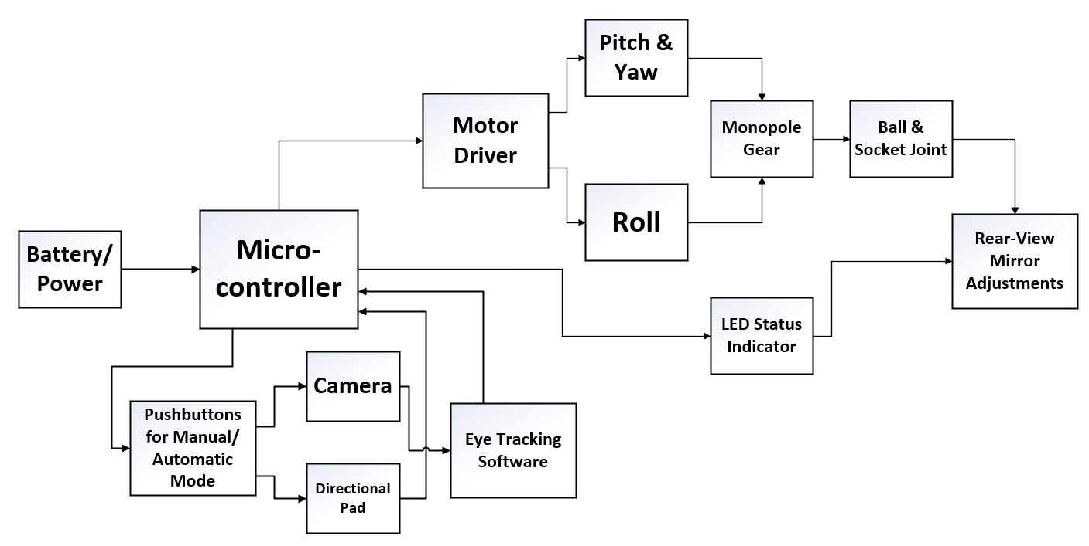

#### **Figure #9: Second Level Block Design**

### **4.2.1 Explanation of Diagram**

The first section of the second level block diagram is where the power is sourced either from a 5V adaptor or a 9V battery for the prototype or from the battery of a motor vehicle for a fully functional product. The next section is the microcontroller where the data is retrieved from the camera to be processed and will then be sent to the motors to move the monopole gear to then readjust the ball & joint assembly finally adjusting the rear-view mirror. Moving down to the next block are the pushbuttons, which allows the driver to adjust the rear-view mirror either by automatic adjustment via the camera and eye tracking software or by using manual operation with the direction pad. The eye tracking software block focuses on locating the eye position of the driver to then send that information for the microcontroller to process and subsequently tell the DC motors to move accordingly.

The motor driver block is the IC used to control the speed and direction of the motors either clockwise or anticlockwise and can drive up to 2 DC motors. The motor block focuses on the DC motors used to control the pitch, yaw and roll of the mirror, where one motor is located on the left side internal wall of the housing unit facing the cabin, which controls the pitch & yaw of the mirror. While the other motor will be located on the back wall of the housing unit which controls the roll of the mirror. The monopole gear block focuses on the gear that will be used for the smooth movement to change the angle of the mirror more seamlessly. The ball & socket joint block focuses on movement for the rear-view mirror when attached to the housing unit allowing for smoother movement when the driver or micro controller is adjusting it. The rear-view mirror adjustment block focuses on the micro adjustments made to the rear-view mirror offering the driver a better viewing angle out of the rear windshield. The LED status indicator block is the small pilot light used as indication for the driver, showing that automatic adjustments are being made once the power has been turned on for the microcontroller.

## 

## **4.3 Schematics**

## 

#### **Figure #10: Schematic**

The schematic of the circuit is a visual representation of the connection between the components of the system.

* The Raspberry Pi 4 microcontroller is connected to the components by the I/O ports and is powered by a battery cell to perform its operation.
* The camera module V2 is connected to the camera I/O pin of the Raspberry Pi and powered by the Raspberry Pi (5V).
* There are 2 LEDs, white and yellow, connected with resistors to regulate the flow of the current and protect the LEDs. The LEDs are connected at ports 21 and 22. The warning light (yellow) LED indicator will blink during the adjustment process to warn the driver to not operate any action until the adjustment is complete.
* The motor driver L293D uses 4 I/O ports and controls the 2 DC motors connected to it. The Raspberry Pi supplies the motor driver with 5V, and a 12V battery will be connected to supply the DC motors.

## **4.4 Flow Charts & Software**

# 

#### **Figure #11: Flowchart**

The main part of the initialization process that needs to be tested is simply checking if the software is able to run in Pi OS just like how it does in Windows. This may seem like a simple task, but because most of the libraries are built with Windows in mind, adding extra libraries and getting the environment setup for Pi OS took extra steps of configurations. As long as the software is operating, the initialization process is ready.

For the preparation step, the dark detection needs to be able to turn on when the car is dark or the face is undetectable. This will require the system being able to detect if the indoor is too dark. It will also need to be able to turn on two forms of lights based on the situation: the camera light when the dark detection is functioning, and the warning light to indicate the start of the process.

## **4.5 Parts Data Sheets**

### **4.5.1 Raspberry Pi 4 Model B datasheet**

#### **Figure #12: Raspberry Pi 4 Model B Pinout Diagram[1]**

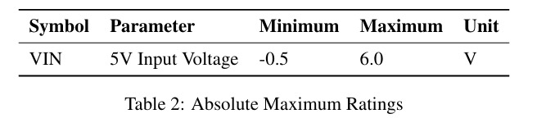

#### **Figure #13: Minimum & Maximum Voltage Input [2]**

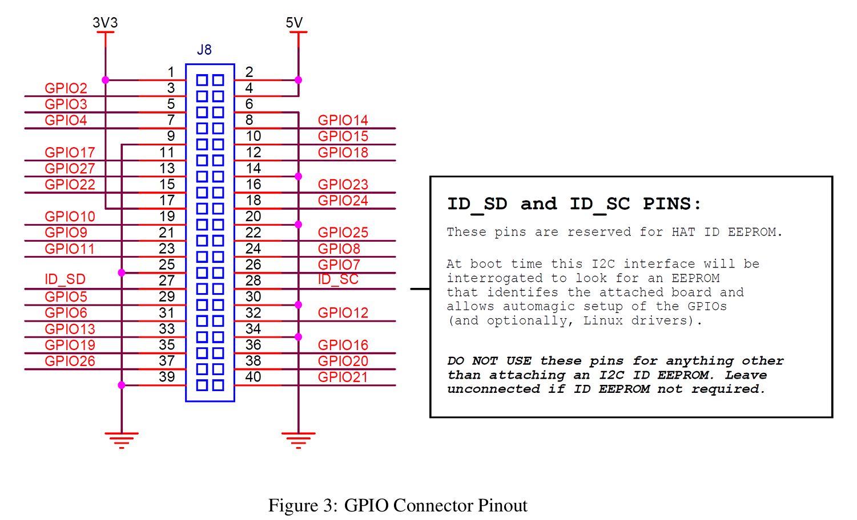

#### **Figure #14: Raspberry Pi Pinout Diagram**[3]

**Specifications (Raspberry Pi Foundation, 2023):**

* 2 × micro HDMI
* 2 × USB 2.0
* 2 × USB 3.0
* CSI camera port
* DSI display port
* 3.5mm AV jack
* PoE-capable Gigabit Ethernet (1Gb/s)
* 2.4/5GHz dual-band 802.11ac Wi-Fi (120Mb/s)
* Bluetooth 5, Bluetooth Low Energy (BLE)
* microSD card slot
* USB-C power (5V, 3A (15W))
* 4GB ram[4]

### **4.5.2 Raspberry Pi Camera Module V2 datasheet**

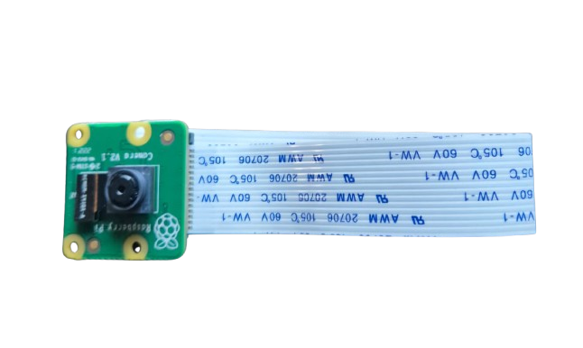

#### **Figure #15: Raspberry Pi Camera Module V2[5]**

**Specifications (Raspberry Pi Foundation, 2023):**

* 8 megapixel camera
* Photographies at 3280 x 2464 pixels
* Videos at 1080p47, 1640 × 1232p41 and 640 × 480p206 resolutions
* Software supports the latest version of Raspbian Operating System
* Sensor: Sony IMX219
* Weight: 3g
* Voltage: 3.3 volts

### **4.5.3 Greartisan Gear Motor datasheet**

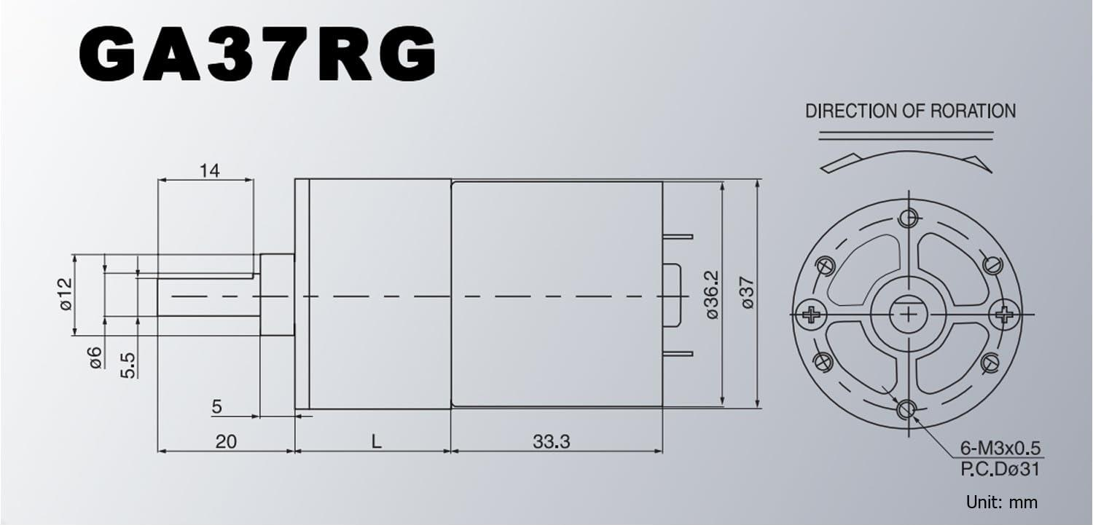

#### **Figure #16: Greartisan DC 12V 50 RPM, 37mm Diameter Gearbox[6]**

**Specifications:**

* Voltage: DC 12V
* Reduction Ratio: 1:401
* No-Load Speed: 50 RPM
* No-Load Current: 0.15 Amp
* Rated Torque: 15 kg/cm
* Rated Current: 0.6 Amp
* D Shaped Output Shaft Size: 6 x 14 mm (0.24” x 0.55”)
* Gearbox Size: 37 x 30.5 mm (1.46” x 1.2”)
* Motor Size: 36.2 x 33.3 mm (1.43” x 1.31”)
* Mounting Hole Size: M3 (not included)

### **4.5.4 3 mm LED Datasheet**

# 

#### **Figure #17: 3mm LED Datasheet[7]**

**Specifications:**

* Power dissipation : 66mW
* Reverse Voltage : 4 V
* D.C. Forward Current:30mA
* Operating Temperature Range:-25 to + 85°C
* Peak Current (1 / 10 Duty Cycle, 0.1ms Pulse Width) :100 mA
* Reverse (Leakage) Current:100 μA
* Luminous Intensity: 20 mA

### **4.5.5 L293D Datasheet**

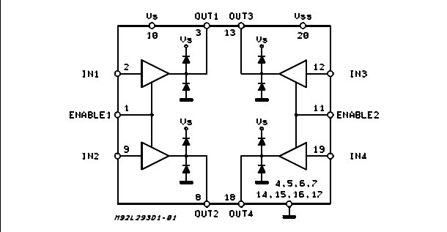

#### **Figure #18: L293D Push-Pull Four Channel Drivers with Diodes, Block Diagram[8]**

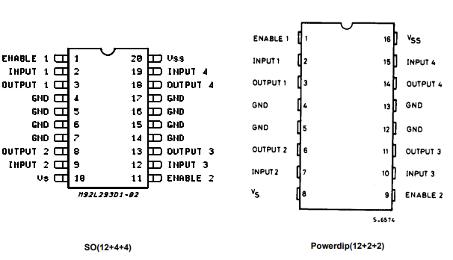

#### **Figure #19: L293D, Pin Connections**

**Specification:**

* Logic Supply Voltage: Min. - 4.5V; Max - 36V
* Total Quiescent Supply Current (pin 10) -Typ. - 2 mA; Max - 6 mA
* Total Quiescent Supply Current (pin 20) -Typ. - 16 mA; Max - 24 mA
* Internal Clamp Diodes
* 600ma Output Current Capability Per Channel
* Enable Facility
* 1.2a Peak Output Current (Non Repetitive) Per Channel
* Logical \"0\" Input Voltage Up To 1.5 V (High Noise Immunity)
* Overtemperature Protection

# 

# **5.0 References**

Raspberry Pi Foundation. (2023). *Raspberry Pi: Camera documentation*. Raspberry Pi.<https://www.raspberrypi.com/documentation/accessories/camera.html>

Raspberry Pi Foundation. (2023). *Raspberry Pi: Specifications*. Raspberry Pi.<https://www.raspberrypi.com/documentation/computers/raspberry-pi.html>

Raspberry Pi Trading Ltd. (2024). *Raspberry Pi 4 Model B datasheet: Release 1.1*.<https://datasheets.raspberrypi.com/rpi4/raspberry-pi-4-datasheet.pdf>

Greartisan Store, Amazon (2024). *Greartisan DC 12V 10RPM Gear Motor 37mm Diameter Gearbox* <https://www.amazon.com/Greartisan-Electric-Reduction-Centric-Diameter/>

Farnell (2024). *3mm LED Datasheet.*<https://www.farnell.com/datasheets/1626756.pdf>

STMicroelectronics (2024) *L293D Push-Pull Four Channel Drivers with Diodes*.   
 <https://www.st.com/en/motor-drivers/l293d.html>

1. [Raspberry Pi 40-pin](https://www.raspberrypi.com/documentation/computers/raspberry-pi.html)
2. [Raspberry Pi 4 Model B Datasheet](https://datasheets.raspberrypi.com/rpi4/raspberry-pi-4-datasheet.pdf)
3. [Raspberry Pi 4 Model B Datasheet](https://datasheets.raspberrypi.com/rpi4/raspberry-pi-4-datasheet.pdf)
4. [Raspberry Pi 4 Model B Datasheet](https://www.raspberrypi.com/documentation/computers/raspberry-pi.html)
5. [Camera Datasheet](https://www.raspberrypi.com/documentation/accessories/camera.html)
6. [Motor Description](https://www.amazon.com/Greartisan-Electric-Reduction-Centric-Diameter/dp/B089GTHGPZ/ref=sr_1_6?dib=eyJ2IjoiMSJ9.DVWk5pLyQ_dqDp13O4lPtXmWJI-1PIDOGCXkdHtBmk8kIkbhaTpLe9H5dfid5uMbi3GzMdo-mdpM9U8yt_FHOFVe13uaeaJHaaeGRUdknU6j9w-tYt_hyOkCkRMPB_9s2DW1F7Xw3hzCqTFcXVQwW-q_n5dNwxl1b7ungHc3w41trYXV6S-P7GOEoIbjEFxIls6oe45XqJGevlB48n9pdQJbXKD7HJbBAeXC8EXyC2a_fwVbRS_tMMk0esKfpy7AN52JDr3jkJSRhn0bDPy_KWWrOlS1TwtlI6wbIr6yOF4.R0z_GKXggYmb6AjWPk86apT7ntOMUQBSAj7IEeFEk3U&dib_tag=se&keywords=high%2Btorque%2Bdc%2Bmotor&qid=1728144444&sr=8-6&th=1)
7. [3mm LED datasheet](https://www.farnell.com/datasheets/1626756.pdf)
8. [L293D Product Overview & Datasheet](https://www.st.com/en/motor-drivers/l293d.html)